Homework 4 – Report

**Programming Exercises**

**Question 1**

**

**Part b**

**Part c**

**

**Part dii**

These are the termination criterion that I chose. The first one ensures that the algorithm will stop after 100 iterations even if convergence isn’t reached to not have infinte loops and just in case the algorithm does not reach convergence. The second criteria determines how well the model fits the data by checking how small the change is. If the change is less than 0.01% then it means the model has reached convergence.

**Part diii**

**

**Part e**

The clusters are ever so slightly different, but still pretty similar other than a few points. A possible reason as to why there’s a differenc is because K-Means clusters in linear boundaries while GMM can have curved boundaries. In this case, that could explain why there’s a few points in the duration around 3.3-3.7 minutes that K-Means classified in the yellow group. Ultimately, GMM has a better performance.

**Question 2**

**Part a**

This part consisted of just downloading the face dataset onto my personal computer.

**Part b**

**Part c**

**

**Part e**

**Part f**

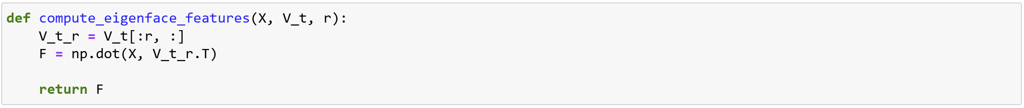

**Part g**

**Written Exercises**

**Question 1**

**Question 2**

**Part a**

**Part b**

**Part c**

**Part d**

**Part e**

